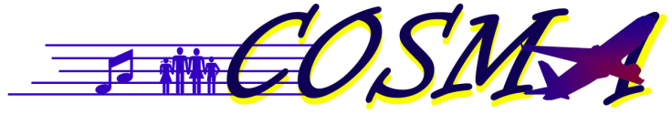

Community Oriented Solutions to
Mimimise Aircraft Noise Annoyance

September 19, 2013

Hotel Grauer Bär
Universitätsstrasse 5 – 7, Innsbruck, Austria

Workshop Registration Form

The achievements of the European project COSMA on community related aircraft noise annoyance will be presented to a broader public audience in a one-day dedicated workshop on September 19, following the Internoise 2013 Conference in Innsbruck.

The workshop is supported by the X-NOISE EV Coordination Action and is therefore registration free.

Participants should simply indicate their interest in attending the workshop by returning through email this Registration Form to dominique.collin@snecma.fr; michael.bauer@eads.net; alexis.aubert@safran-engineering.com before August 30.

We definitely look forward to seeing you in Innsbruck,
The Workshop Organizing Committee

Name:
Organisation:
Phone:
Fax:
E-mail:

